Peter Zhang

(240) 994-2204

[petejzh@gmail.com](mailto:petejzh@gmail.com)

December 23, 2020

Dear Hiring Manager,

I am writing express my interest in the security research engineering internship with the Content IPS team. I am a Computer Science student at UC Berkeley with an interest in high-impact, quantitative projects. I believe that my technical and interpersonal skills align with the needs of the team.

Last Spring, I interned at the National Cancer Institute with the goal of converting an antiquated web-based data analysis tool to an updated, desktop application. When the team struggled to get permission for me to access the data, I chose instead to scrape the dataset from the website and reformat the database for efficiency. Over the following two months, I built the app with R and Electron, meeting regularly with the team for feedback and testing. The process instilled a background in networking, software design, and problem-solving.

Last summer, I assisted the development an online cost-benefit analysis tool at the National Institute of Standards and Technology. To guide users, I wrote a case study of wildfire-resistant retrofitting for a vulnerable community in California. I bug-tested the software and worked with reviewers to publish a 20-page user manual. The research and writing process taught me communication skills and attention to detail, making me an effective debugger and team member.

I currently work as a part-time debate coach at The Bronx High School of Science. In weekly practices and one-on-one drills, I give students the knowledge and confidence succeed in Lincoln-Douglas debate. Since beginning in August, I endeavored to inspire passion and discipline in the team, ultimately helping multiple students achieve success at national tournaments. I plan to bring the same empathy, patience, and persistence to my work this summer.

I draw on numerous technical experiences to contribute thorough and creative work in a timely manner and I excel in team projects by coordinating and empathizing with co-workers. I am fully confident that my passion and skillset fit perfectly with the goals of the Content IPS team. Please do not hesitate to contact me for questions or additional materials. Thank you in advance for your time and consideration.

Sincerely,

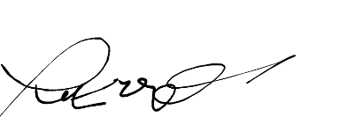

Peter Zhang